**ANONYMIZE FILE BY SELECTING IT FROM COMPUTER**.

Sharing the script with following functionality-(anonymize-file.py)

Select file from your computer and anonymize the data element choosing from the given category-

**Step 1-**

Run the below file  on cmd using-

python anonymize-file.py

On running following dialog box appears-

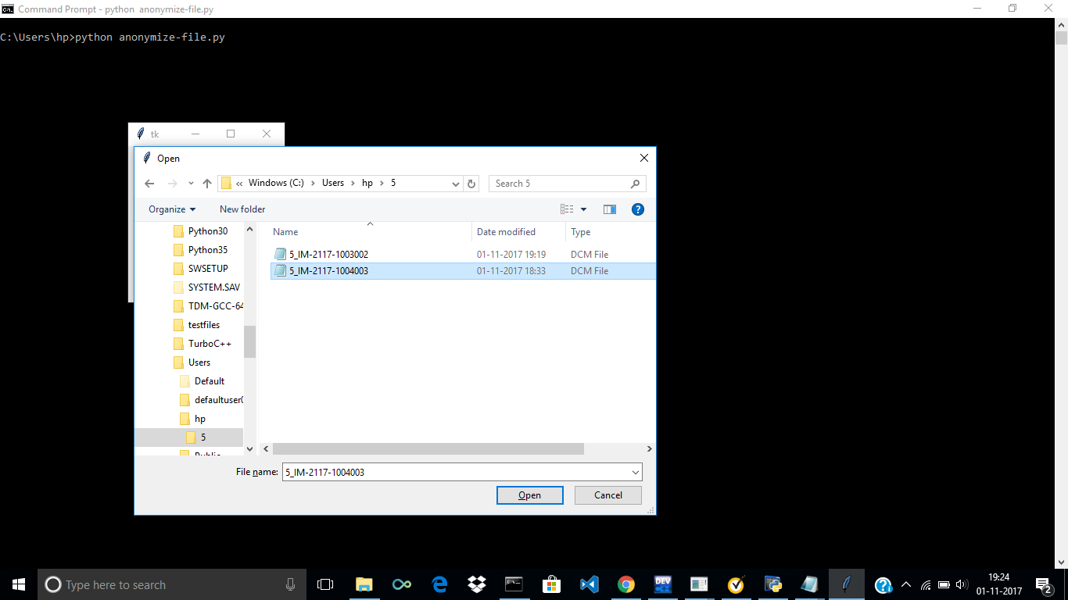

**Step 2-**

Browse the file you want to select-

**Step 3-**

click Open

**Step-4**

Enter the category-

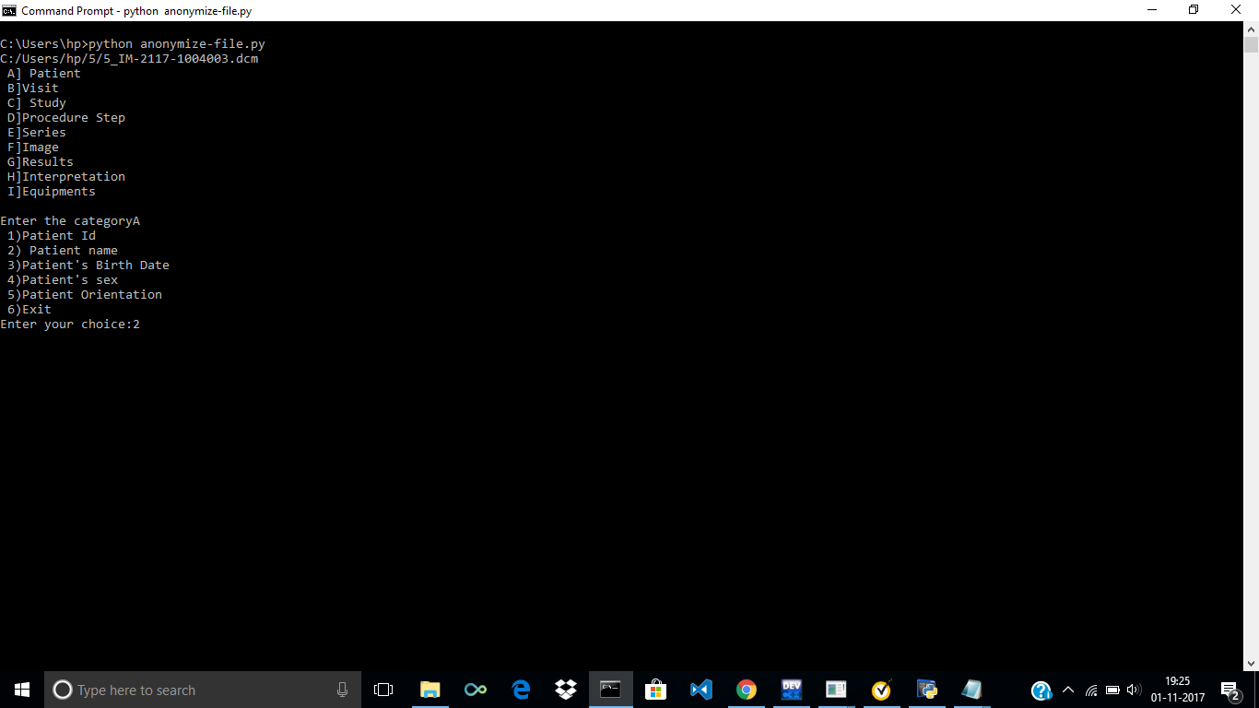

**Step-5**

Select your choice.

*Enter the category***A**

 1)Patient Id

 2) Patient name

 3)Patient's Birth Date

 4)Patient's sex

 5)Patient Orientation

 6)Exit

*Enter your choice:***2**

**OUTPUT---**

2

### Now reading file: C:/Users/hp/5/5_IM-2117-1004003.dcm

*(0010, 0010) Patient's Name                      PN: 'pat_name'*

Here, Patients name get anonymized..

Similarly anonymize the other data set by choosing your file  located anywhere inside your computer,

Thanks